DATA ANALYST INTERN – PHASE 2 (INTERMEDIATE) TASK REPORT
Objective
The objective of Phase 2 (Intermediate Intern Tasks) was to advance my data analytics skills beyond the basics by combining strong theoretical understanding with real-world practical implementation. This phase focused on developing business-oriented analytical thinking, working with structured datasets, performing SQL-based analysis, creating interactive dashboards, and communicating insights clearly in a professional format. The goal was to simulate real responsibilities of a Data Analyst in an industry environment.

PART A: THEORETICAL TASKS
1. End-to-End Data Analysis Lifecycle Using a Real Business Example
The end-to-end data analysis lifecycle represents the complete analytical workflow followed by data analysts in real organizations. It ensures that data-driven decisions are accurate, meaningful, and aligned with business objectives.
Stages of the Data Analysis Lifecycle
- Business Problem Definition
This is the most critical step where analysts understand business needs. The problem must be clearly defined in measurable terms.
Example: “Why has profit declined in certain regions despite high sales?”
- Data Collection
Data is gathered from internal systems (databases, CRM, ERP), flat files (CSV, Excel), APIs, or third-party platforms.
- Data Cleaning and Preparation
Raw data often contains missing values, duplicates, incorrect data types, and inconsistencies. Cleaning ensures data accuracy and reliability.
- Exploratory Data Analysis (EDA)
Analysts explore patterns, trends, and relationships using descriptive statistics and visual summaries.
- Data Analysis and Interpretation
Analytical and statistical techniques are applied to derive insights and answer business questions.
- Data Visualization and Reporting
Insights are presented using charts, dashboards, and reports that are easy to understand for stakeholders.
- Business Decision and Action
Stakeholders use insights to take strategic actions such as pricing changes, marketing focus, or operational improvements.

Real Business Example
A retail company analyzes its sales and profit data to identify underperforming regions. After analysis, the company adjusts discount strategies and reallocates marketing budgets to high-profit regions.

2. Differentiation: Descriptive vs Diagnostic Analytics
Descriptive and diagnostic analytics are two important types of analytics used in business decision-making. While both focus on understanding data, they serve different purposes.
Comparison Table: Descriptive vs Diagnostic Analytics
Aspect | Descriptive Analytics | Diagnostic Analytics
Purpose | Explains what happened in the past | Explains why it happened
Focus | Historical data summary | Root cause analysis
Type of Questions | “What happened?” | “Why did it happen?”
Examples | Total sales, average profit, monthly revenue | Reasons for profit drop, impact of discounts
Output | Reports, dashboards, summaries | Deeper insights and explanations
Business Value | Helps understand performance | Helps improve performance
Descriptive analytics provides a summary of historical data, such as total sales or average profit, and is often used in dashboards and reports. Diagnostic analytics goes a step further by analyzing the reasons behind outcomes, such as identifying why profit declined or why certain regions underperformed.
- Differentiation: Correlation vs Causation
Correlation and causation are commonly misunderstood concepts in data analytics. Understanding the difference between them is essential to avoid incorrect conclusions.
Comparison Table: Correlation vs Causation
Aspect | Correlation | Causation
Meaning | Two variables move together | One variable directly causes change in another
Relationship | Association only | Cause-and-effect
Direction | Can be positive or negative | Direct influence
Example | Discount and profit move together | Discount directly reduces profit
Risk | Can lead to false conclusions | Requires strong evidence
Business Use | Identifies patterns | Supports decision-making
Correlation indicates a relationship between variables, but it does not prove that one causes the other. For example, discounts and profit may be correlated, but other factors such as product cost or market demand may influence profit. Causation requires deeper analysis and evidence to confirm a direct relationship.
3. Short Notes (Paragraph Format)
Data Bias occurs when the data collected does not accurately represent the real-world scenario. Biased data can result from incomplete data collection, sampling errors, or human assumptions. If bias is not identified and corrected, it can lead to misleading insights and poor business decisions.
Missing Data Strategies are used to handle incomplete datasets. Common strategies include removing records with missing values, filling missing values using statistical measures such as mean or median, or applying forward and backward filling for time-series data. The choice of strategy depends on the nature and importance of the missing data.
KPIs vs Metrics: Metrics are raw measurements such as sales, profit, or revenue, while Key Performance Indicators (KPIs) are specific metrics that are directly linked to business goals. KPIs help organizations track performance and measure success against objectives.

4. Case Study: Why Dashboards Fail Even with Correct Data
Dashboards can fail even when the underlying data is accurate due to poor design and lack of business context. Common reasons include overcrowded dashboards with too many metrics, inappropriate chart selection, unclear labels, and absence of insight summaries. A successful dashboard focuses on clarity, relevance, and actionable insights rather than displaying excessive data.

PART B: PRACTICAL TASKS

TASK 1: BUSINESS DATASET ANALYSIS (PYTHON)
Dataset Used
Global Superstore Sales Dataset (Kaggle)
https://www.kaggle.com/datasets/vivek468/superstore-dataset-final

Step 1: Load Dataset
import pandas as pd
df = pd.read_csv("Sample - Superstore.csv", encoding="latin1")
df.head()
df.info()
Python notebook showing dataset loaded and structure
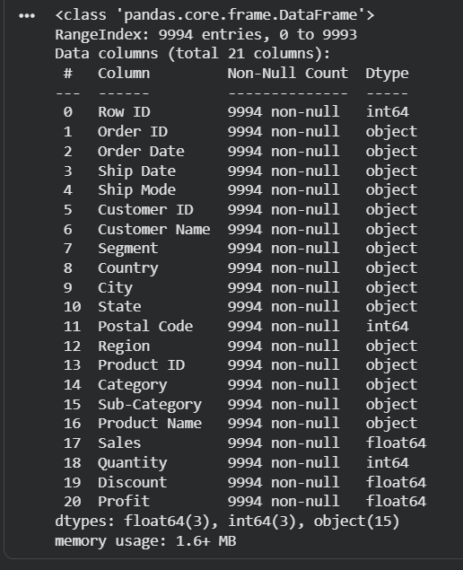
Step 2: Data Cleaning
df.dropna(inplace=True)
df.drop_duplicates(inplace=True)
df['Order Date'] = pd.to_datetime(df['Order Date'])
df['Ship Date'] = pd.to_datetime(df['Ship Date'])
Data cleaning code and df.info() output
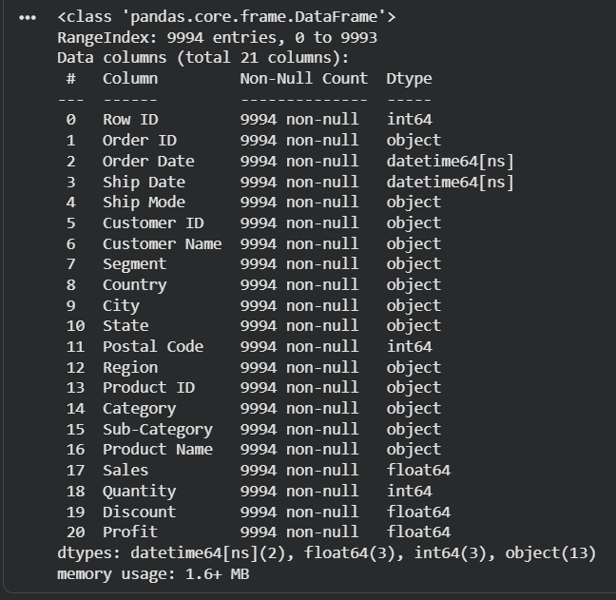

Step 3: Business Questions and Analysis
Q1: Which category has the highest sales?
df.groupby('Category')['Sales'].sum()
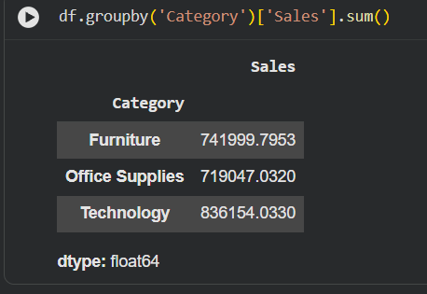
Q2: Which region is the most profitable?
df.groupby('Region')['Profit'].mean()
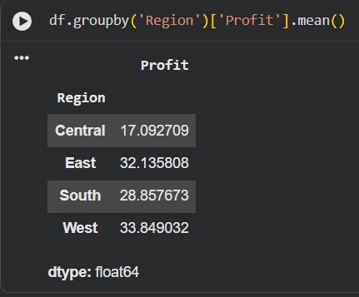
Q3: How does discount affect profit?
df[['Discount','Profit']].corr()
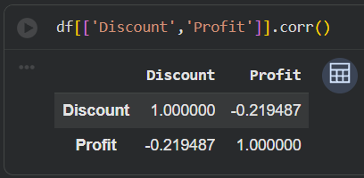

Q4: Which sub-category performs poorly?
df.groupby('Sub-Category')['Profit'].sum().sort_values()
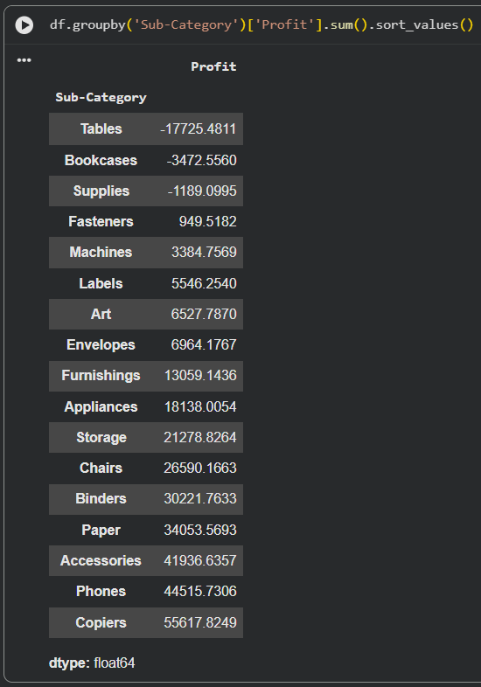
Q5: What is the sales trend over time?
df.groupby(df['Order Date'].dt.year)['Sales'].sum()
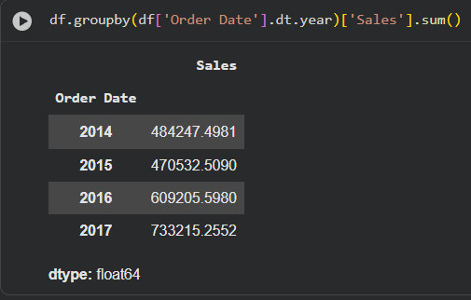
TASK 2: SQL CHALLENGE (Using Manual Data Insertion)
🔹 STEP 1: Create Database
CREATE DATABASE superstore_db;
USE superstore_db;
Database creation query executed successfully
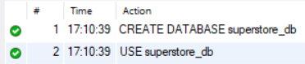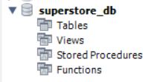
🔹 STEP 2: Create Sales Table
CREATE TABLE sales (
OrderID INT,
Category VARCHAR(50),
SubCategory VARCHAR(50),
Region VARCHAR(50),
Sales DECIMAL(10,2),
Profit DECIMAL(10,2)
);
Table creation query executed successfully
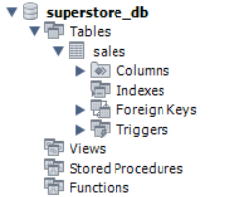
🔹 STEP 3: Insert Business Data (Manually)
Now insert realistic sample business data:
INSERT INTO sales VALUES
(1001, 'Office Supplies', 'Binders', 'West', 250.00, 45.00),
(1002, 'Technology', 'Phones', 'East', 1200.00, 300.00),
(1003, 'Furniture', 'Chairs', 'South', 800.00, 120.00),
(1004, 'Office Supplies', 'Paper', 'West', 150.00, 30.00),
(1005, 'Technology', 'Accessories', 'North', 600.00, 150.00),
(1006, 'Furniture', 'Tables', 'East', 950.00, 80.00),
(1007, 'Office Supplies', 'Storage', 'South', 400.00, 60.00),
(1008, 'Technology', 'Machines', 'West', 2000.00, 500.00),
(1009, 'Furniture', 'Bookcases', 'North', 700.00, 100.00),
(1010, 'Office Supplies', 'Art', 'East', 300.00, 40.00);
Check inserted data:
SELECT * FROM sales;
Insert query + table preview output
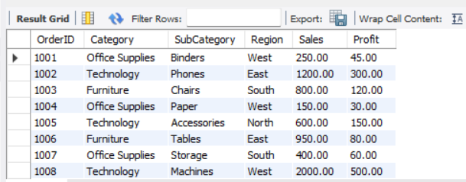
🔹 STEP 4: GROUP BY Query (Region-wise Sales)
SELECT Region, SUM(Sales) AS TotalSales
FROM sales
GROUP BY Region;
Business Insight:
West region contributes significantly to overall revenue.
GROUP BY Region output
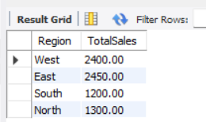

🔹 STEP 5: GROUP BY Query (Category-wise Profit)
SELECT Category, AVG(Profit) AS AvgProfit
FROM sales
GROUP BY Category;
Business Insight:
Technology category shows higher average profit compared to others.
GROUP BY Category output
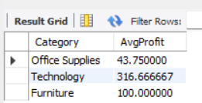
🔹 STEP 6: SUBQUERY 1 – Categories with Above Average Sales
SELECT Category
FROM sales
GROUP BY Category
HAVING SUM(Sales) >
(
SELECT AVG(TotalSales)
FROM (
SELECT SUM(Sales) AS TotalSales
FROM sales
GROUP BY Category
) AS avg_table
);
Insight:
Identifies top-performing product categories that exceed overall average sales.
Subquery 1 result
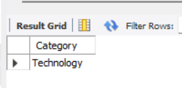

🔹 STEP 7: SUBQUERY 2 – Most Profitable Region
SELECT Region
FROM sales
GROUP BY Region
HAVING SUM(Profit) =
(
SELECT MAX(TotalProfit)
FROM (
SELECT SUM(Profit) AS TotalProfit
FROM sales
GROUP BY Region
) AS profit_table
);
Insight:
Highlights the best-performing region in terms of total profit.
Subquery 2 result
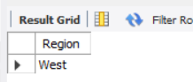

🔹 STEP 8: SUBQUERY 3 – Sub-Categories with Below Average Profit
SELECT SubCategory
FROM sales
GROUP BY SubCategory
HAVING AVG(Profit) <
(
SELECT AVG(Profit)
FROM sales
);
Insight:
Identifies underperforming product segments that require business attention.
Subquery 3 result
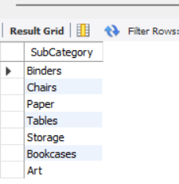
TASK 3: DATA VISUALIZATION (POWER BI)
Tool Used
Microsoft Power BI Desktop
Step 1: Load Data
Open Power BI Desktop
Get Data → CSV / Excel → CRM Sales Opportunities Dataset
Data loaded in Power BI (Data View)
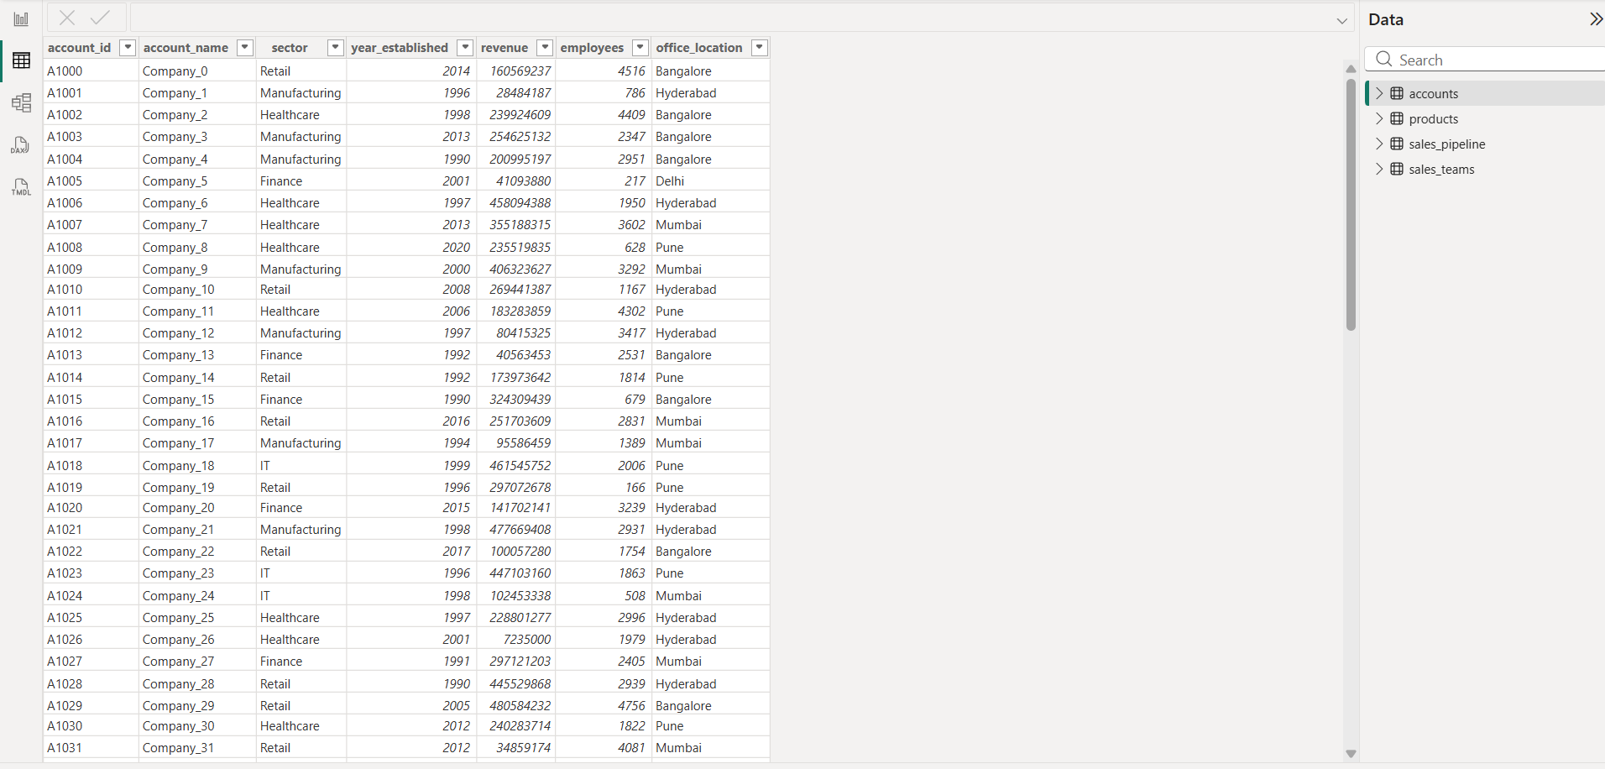
Step 2: KPI Cards
Create KPI cards for:
Total Deals
Total Revenue
Average Deal Value
Average Deal Duration (Days)
KPI cards section
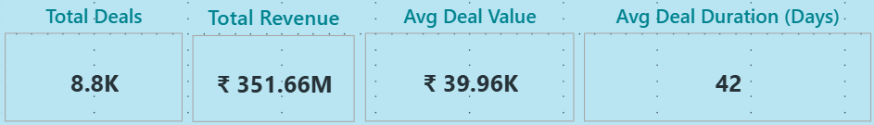
Step 3: Deal Stage Analysis
Bar chart: Count of opportunity_id by deal_stage
Deal stage bar chart
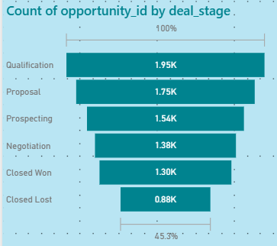
Step 4: Trend Analysis
Line chart: Monthly Deal Value Trend
Monthly revenue trend line chart
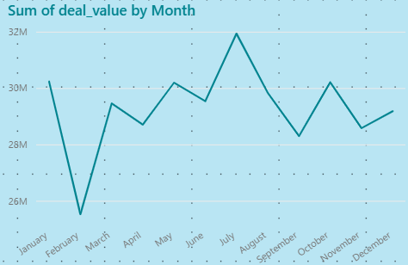
Step 5: Sales Agent Performance
Horizontal bar chart: Sum of deal_value by sales_agent
Sales agent performance chart
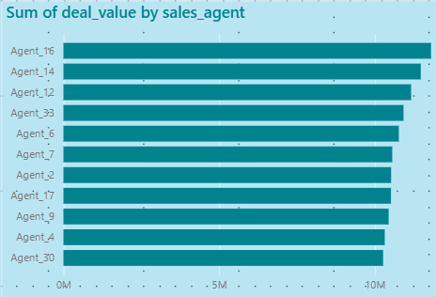
Step 6: Product Performance
Column chart: Sum of deal_value by product_name
Product-wise revenue chart
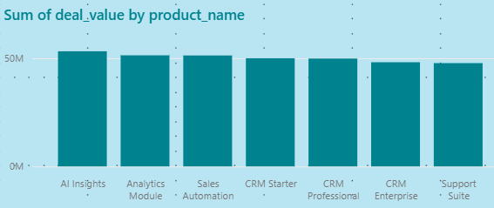
Step 7: Deal Status Distribution
Donut chart: Count of opportunity_id by deal_status
Deal status donut chart
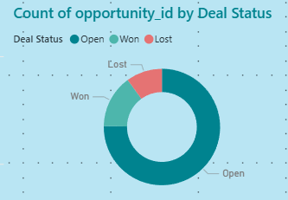
Step 8: Regional Analysis
Pie chart: Count of opportunity_id by regional_office
Regional distribution pie chart
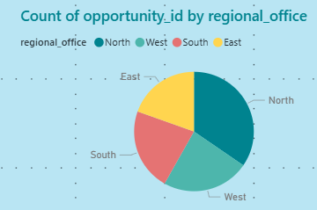
Step 9: Filters (Slicers)
Sales Agent
Year
Sales Agent and Year slicers
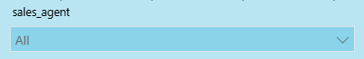
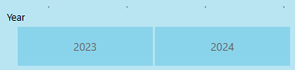
Final Dashboard Overview
After arranging all visuals, KPI cards, and slicers into a structured layout, the dashboard provides a complete CRM opportunity performance overview.
Full CRM Opportunity Analysis Dashboard (Complete View)
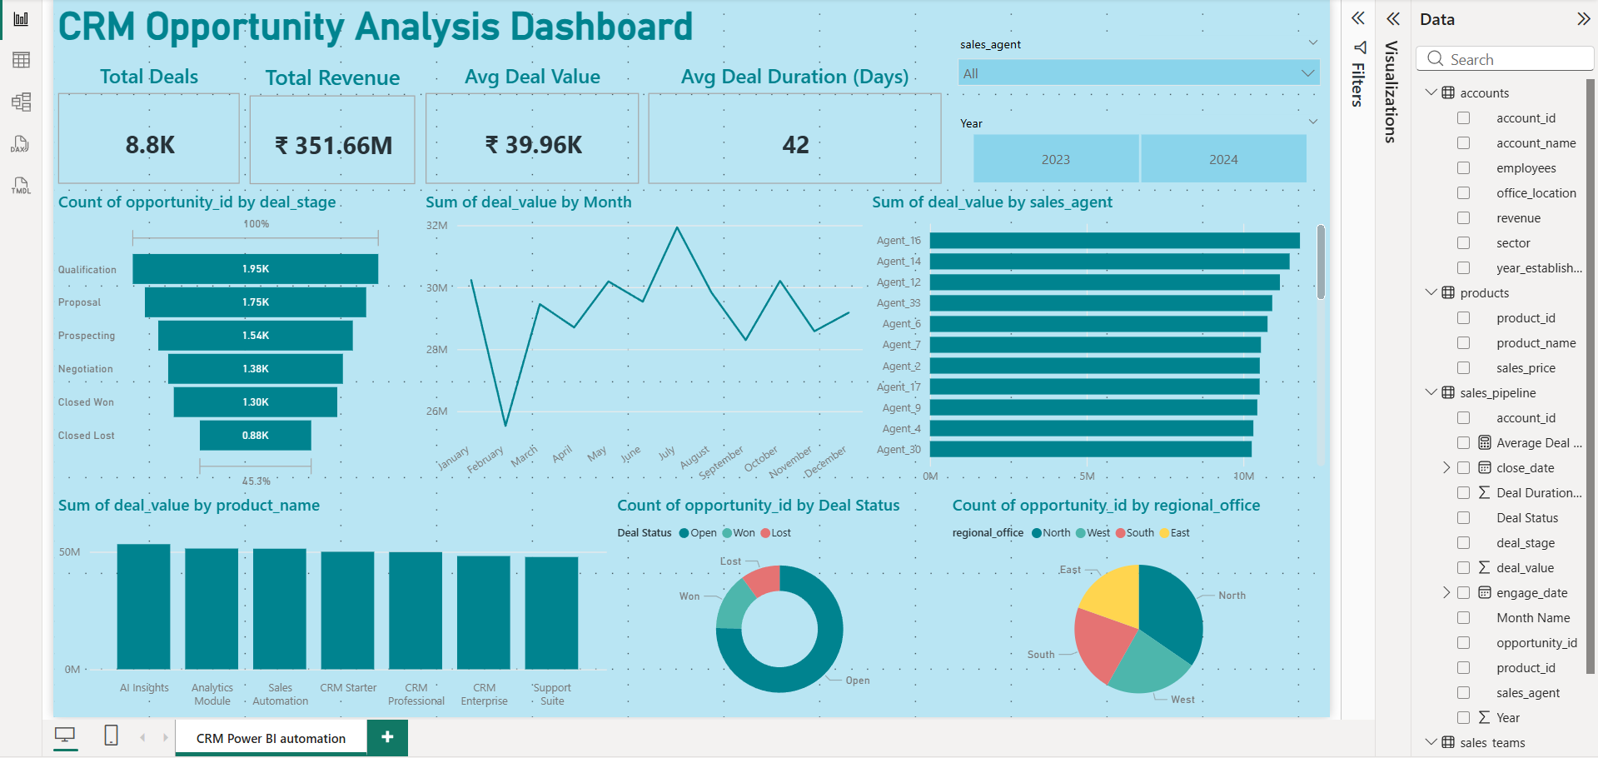

INSIGHT SUMMARY (NON-TECHNICAL LANGUAGE)
• Most deals are in early pipeline stages (Qualification & Proposal).
• Revenue varies month-to-month, showing sales fluctuations.
• A few sales agents generate significantly higher deal value.
• Premium CRM and analytics products contribute major revenue.
• Many deals remain open, indicating future revenue potential.
• North and West regions show strong sales performance.

Learning Outcomes
- Strengthened Python & SQL skills
- Built professional Power BI dashboards
- Learned business-oriented analysis
- Improved insight communication

Reflection
The intermediate phase enhanced my understanding of how Data Analysts work with real business data. It helped me transition from technical execution to business-driven analytics by integrating Python, SQL, and Power BI into a complete analytical workflow.

